I.
1.
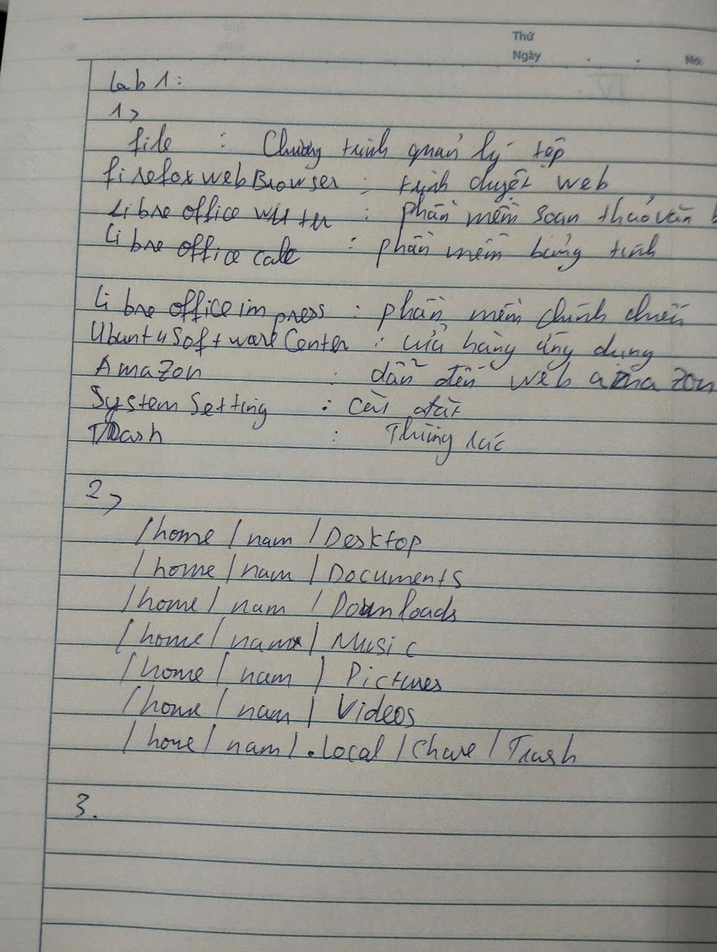
3.
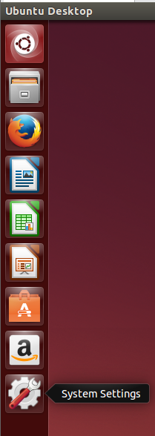
4.
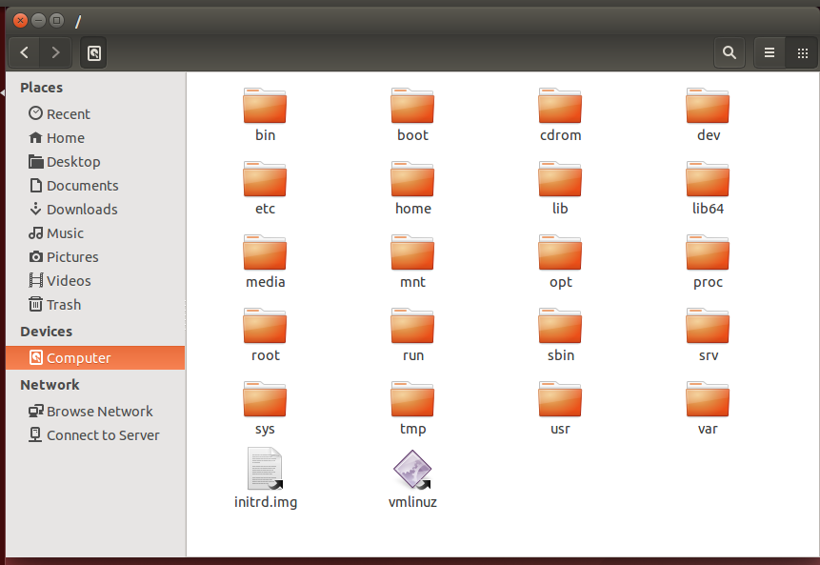
bin: /bin
boot: /boot
cdrom: /cdrom
dev: /dev
etc: /etc
home: /home
lib: /lib
lib64: /lib64
media: /media
mnt: /mnt
opt: /opt
proc: /proc
root: /root
run: /run
sbin: /sbin
srv: /srv
sys: /sys
tmp: /tmp
usr: /usr
var: /var
5.
Không thêm được
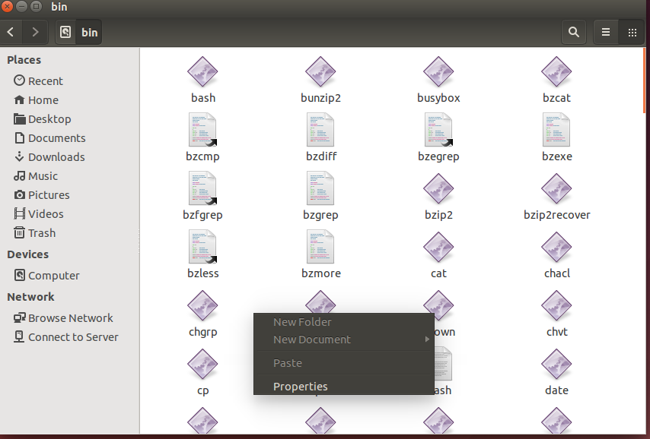
6.
Không có /home/nam
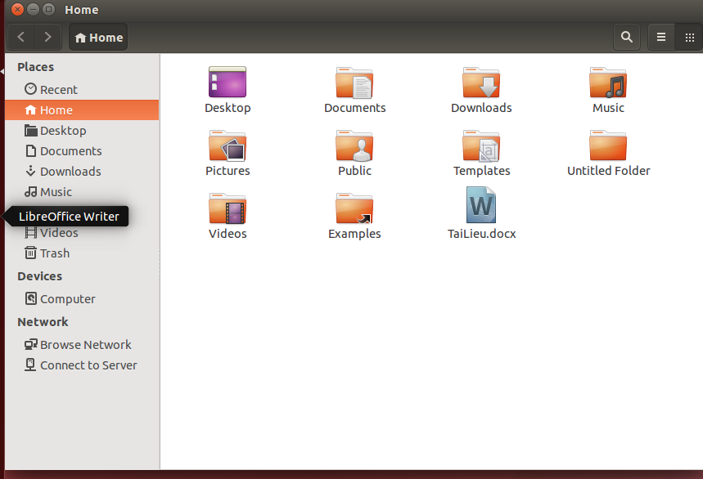
7.
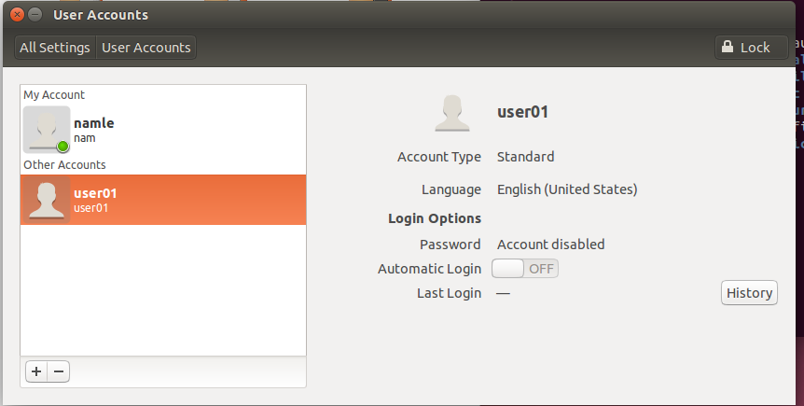
8.

9.
Có thể chuyển đổi nền Terminal thành dạng hình ảnh
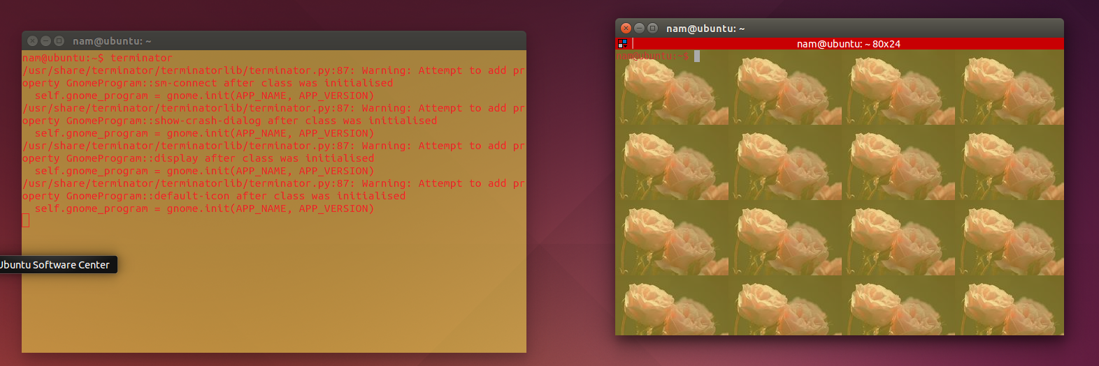
10.
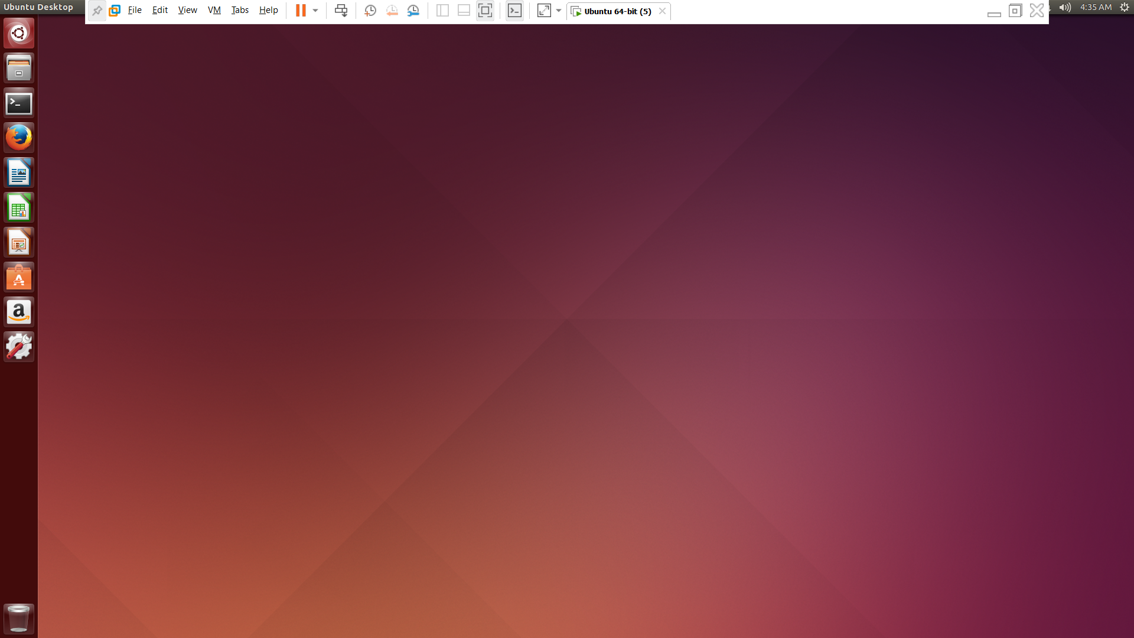
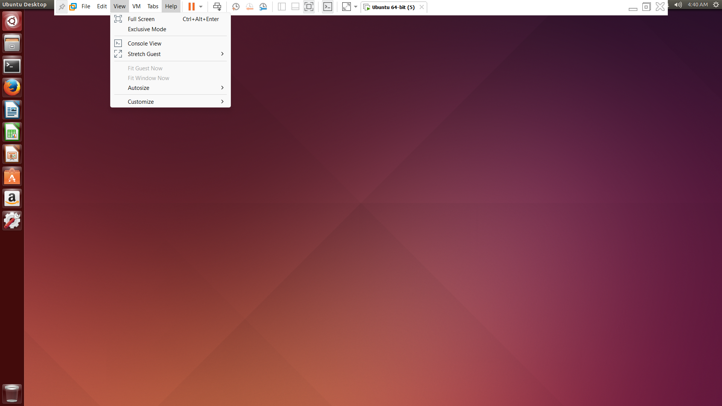
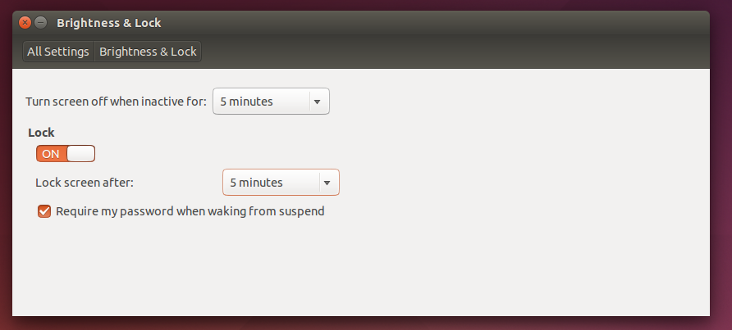
II.
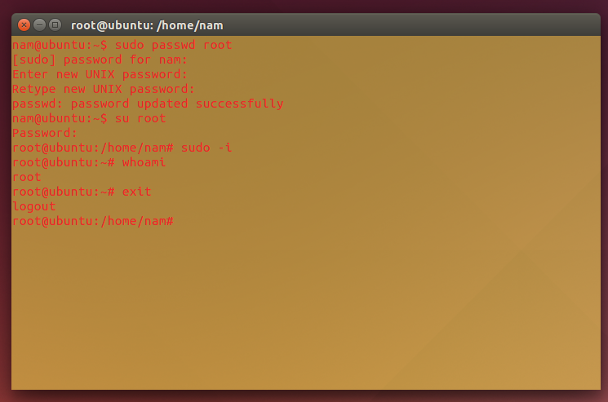
III.
1.Không điều chỉnh được
2. Không điều chỉnh được
3. Không thể cài đặt , gỡ chương trình
4.Không thể thêm 1 tài khoản khác
IV.
Launcher
- Super (Hold) : Opens the Launcher, displays shortcuts.
- Alt + F1 : Opens Launcher keyboard navigation mode.
- Super + Tab : Switches applications via the Launcher.
- Super + 1 to 9 : Same as clicking on a Launcher icon.
- Super + Shift + 1 to 9 : Opens a new window in the app.
Dash
- Super (Tap) : Opens the Dash Home.
- Super + A : Opens the Dash App Lens.
- Super + F : Opens the Dash Files Lens.
- Super + M : Opens the Dash Music Lens.
- Super + C : Opens the Dash Photo Lens.
- Super + V : Opens the Dash Video Lens.
- Super + T : Opens the Trash.
- Ctrl + Tab : Switches between Lenses.
- Arrow Keys : Moves the focus.
- Enter : Opens the currently focused item.
HUD & Menu Bar
- Alt (Tap) : Opens the HUD.
- Alt (Hold) : Reveals the application menu.
- Alt + F10 : Opens the indicator menu.
- Cursor Left or Right : Moves focus between indicators.
Windows
- Super + W : Spreads all windows.
- Ctrl + Super + D : Minimises all windows.
- Ctrl + Super + Up : Maximises the current window.
- Ctrl + Super + Down : Restores or minimises the current window.
- Ctrl + Super + Left or Right : Semi-maximise the current window.
- Ctrl + Alt + Num (keypad) : Places the window in corresponding position.
- Alt + Left Mouse Drag : Moves the window.
- Alt + Middle Mouse Drag : Resizes the window.
Switching
- Alt + Tab : Switches between applications.
- Alt + ` (backtick) : Switches windows of current applications.
- Alt + F4 : Closes the current window.
- Alt + Space : Opens the window accessibility menu.
- Cursor Left or Right : Moves the focus.

V.
